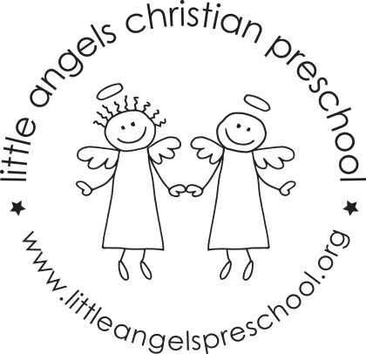

May 2022 Newsletter
Wow, this school year has just whizzed by, we can’t believe that it is May already!
It has been a great year, we have really enjoyed getting to know all of the children and we are so proud of how they adapted to all the changes due to Covid
During May, our themes will be Mothers and families, The Three Little Pigs, The Three Bears and we will finish with kids choice week. During this week we will have some Christmas and other holiday themed table toys and we will sing “The Pumpkin on the Vine” and some other favorite songs and stories the children have especially enjoyed this year.
For art we will be working on a special project, finger painting, decorate a bear shape and paint with straw and twigs. We will also have free choice art during the last week. Our dramatic play area will be housekeeping with babies and strollers, a bear cave and we will also have phones and cameras out for the children to use.
We will be reading “Biscuit Loves Mother’s Day”, “A Family is a family is a family” “The Three Little Pigs”, “Goldilocks and The Three Bears” along with some of the children’s favorite stories, songs and flannel boards they have enjoyed this year.
We hope you will be able to join us for the end of year picnic on Friday May 27th. More details to follow.
Thank you for sharing your children with us and have a great summer.

Martha Carroll and Maggie Killick

