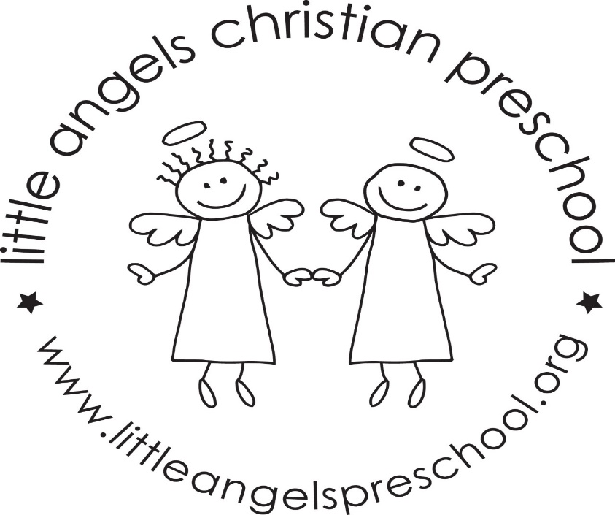
Welcome back! We hope everyone had a great spring break! We have a lot of fun things planned for the month of April.
This month our themes will be Easter and spring themes, as well as celebrating Week of the Young Child. During the week of the Young Child we celebrate a different theme each day, beginning with jeans and tye dye, Tuesday is hat day, Wednesday will be Wacky Wednesday, Thursday farmer/gardener day, and Friday is favorite sports team day. Family Fun night will be Thursday April 7, beginning at 5:30 and ending at 7. Pizza will be served, and we’ll have musical guest ‘Miss Jamie’.
On April 4 artwork will be displayed in
No school on April 14 and 15. We will have parent/teacher conferences on April 14. And April 15 we will be closed for Good Friday.
On April 21 and 22nd we will celebrate meeting all of the letter people! We will have a letter people party! The classroom will have many different letter activities and puzzles, and of course a dance party. We’ll have a special snack with letters on it (cookies).
Thank you for sharing your child with us, and if you ever have any questions we are always available!
Mrs Dreys & Mrs Gierthy

