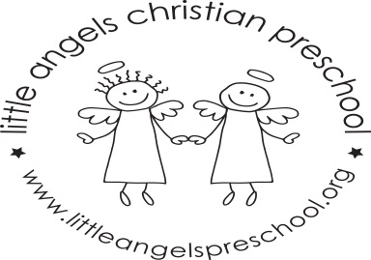
March Newsletter

Dear Parents,
Spring will be here soon, hopefully!!
During March our themes will be dinosaurs, vehicles and construction, “St. Patrick’s Day” and spring. We will have a grocery store, construction area, and housekeeping in our dramatic play area. For St Patrick’s Day we will have green table covers, napkins, plates and some green dress up items for the children to enjoy.
For art we will be painting with dinosaurs, using tempera paint sticks, decorating a flower shape and we will experiment mixing together blue and yellow paints. We have a variety of table toys including a dinosaur sort and count, puzzles, play dough, hammer and nails and some matching games. We will sing “Johnny Hammers with One Hammer”, “The Wheels On The Bus” and enjoy some fun flannel board stories and books. We will also continue our weekly music class with Ms Julia.
There is no school on Friday March 18th and for the week of March 21st due to Spring Break. We hope you have a wonderful and safe break wherever you are spending it. As always, please do not hesitate to call, email or stop by with any questions or concerns.
Martha Carroll and Maggie Killick

