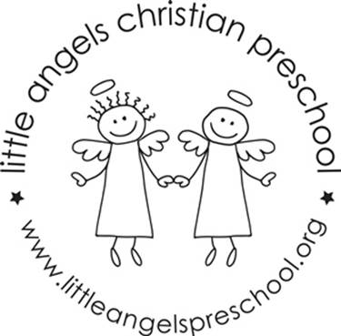
March 2022
Three-year old class newsletter

Welcome to March! We have some pretty exciting things planned this month. Mostly we will be talking about our Five senses. We have a lot of fun activities and learning involving seeing, taste, smell, touching and hearing!

We will be having in person chapel with Father Jesse on March 1 and 2 for Ash Wednesday. Your child can choose to get ashes on their forehead or a special card from the church.

Our classroom will have beach day the week before Spring Break! On March 10/11 we will have our room set up for a fantastic day of fun in the ‘sun’. We will be closed for Spring Break March 18-25. Also in the month of March, Irish dancers will be visiting our school!

We will continue meeting letter people this month, T,U, and V.

Please make sure that your child has two weather appropriate changes of clothes in ziplock baggies. Also, please make sure that all items are labeled with your child's name.

We have an email address for our classroom. We will only check it before and after class. So, if you have something that you need us to know right away, you should call the school office: (847)381-5490. If it's something that does not need immediate attention, please feel free to use our classroom email. The address is: threes@littleangelspreschool.org

Thanks,
Anne Gierthy and Sue Dreys

