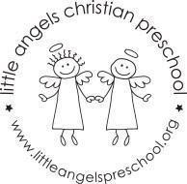
March 2022
Toddler Newsletter – Loppnow/Newman/Katzbeck

Hello, Toddler Parents! We are hoping to head into spring this month with more outdoor time for our toddlers. Assume we will go out daily and pack the appropriate attire according to the weather. March fun will kick off with learning and playing opportunities exploring pets, zoo animals, St. Patrick’s Day, the color green and rainbows.

Please let us know if your toddler is starting to use the potty at home. We do have a toddler sized toilet in our changing room in our classroom.

We are seeing the toddlers learn and grow so much since the fall. It is fun to see them interacting more and moving into more imaginative play. We will send home a write up in April based on our observations of your toddlers in various areas of development. You can also sign up for a ten minute conference where we can talk about our observations and any concerns/questions you may have. Let us know if you can’t make the day and would like to reschedule.

Reminder dates:
Spring Break- No school March 18-25.
Little Angels school wide family event- April 7
Parent/Teacher conferences- Thursday April 14 during school hours, sign up sheet coming soon.

Your Toddler Teachers,
Laura Loppnow, Lynda Katzbeck and Jenn Newman

