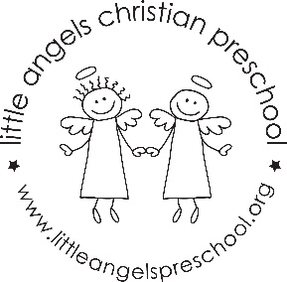
February 2022
Three-Year-Old Class

It’s hard to believe that February is already here! We are starting this month talking about Groundhogs/Shadows/black and white. We will also talk about Valentine’s Day. We will use a real stethoscope and look at a picture of a real heart. We will talk about how to mend “broken” hearts – and show a little love. At the end of the month we will start exploring our 5 senses.
We will introduce a few more Letter People – P, Q, R and S. We are really working our way through the alphabet. The children are doing a great job recognizing their name (without their picture attached) and we are working on having them write their own names on their art work.
We will be adding a kindness board to our room. We love to “catch” the children demonstrating kindness to one another.
Reminders:
February 10 (Thursday) and February 14 (Monday) are our Valentine’s parties.
February 18 and 21 we will not have school. Please let us know if you are traveling.
Be sure to keep checking our daily journal entries and pictures on Shutterfly to see what’s happening in our room. We have been super busy and having lots of fun!
Thank you for keeping your child home if they aren’t feeling well. This and the daily cleaning seems to really be helping keep our classroom Covid free!

Stay warm, safe and heatlhy!
Your Threes teaching team – Sue Dreys and Anne Gierthy

