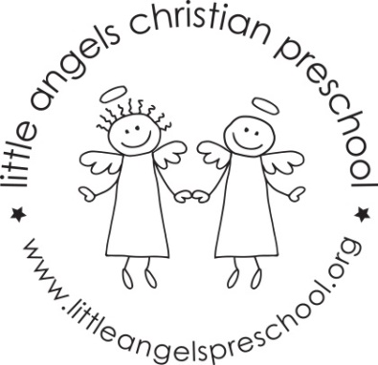
Newsletter January 2022
Happy New Year!
Dear Parents,
Welcome back, we hope you had a safe and blessed Christmas. Thank you all so much for the generous and thoughtful gifts, we really appreciate them.
For January we have some fun activities planned for the children, our themes will be snow, ice and snowmen, penguins and we finish the month with a Jungle theme.
Our art activities will include vehicle painting, using brushes with glitter paint, chalk, making a collage and painting with frozen paints. We will build with a variety of different blocks and have white shredded paper, some toys frozen in an ice block, snow and colorful packing peanuts with animals in our sensory trays. To further develop our fine motor skills we will work with glue sticks, play dough, manipulative toys and puzzles.
Our dramatic play area will include a doctor’s office, cameras, phones and some really cute animal masks.
At group time we will be reading “A Silly Snowy Day”, “Peekaboo Penguins” and “Giraffes Can’t Dance” along with some flannel board stories and fun group games.
Reminder, please label and put hats, gloves etc. into the sleeve of your child’s coat. Thanks!
Reminder: No school Monday Jan 17th – Martin Luther King Day
Martha Carroll and Maggie Killick

