Little Angels 2’s December newsletter

Happy Holidays! 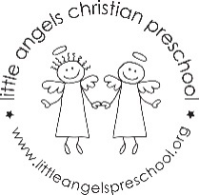
Most of the month our focus will be on Christmas. We will talk about the Nativity, stars, bells and the colors red and green. We will be introducing new process art projects and sensory activities for the children to enjoy. Our table activities will be focused on matching, sorting and other fine motor skills. At group time we have new games and new flannel board stories and songs. It will definitely be a busy month and we look forward to spending this magical time of year with your children.
December 20th and 21st are the Holiday parties in the classroom.
Please let us know at any time if you have questions or concerns.

Martha Carroll and Maggie Killick

