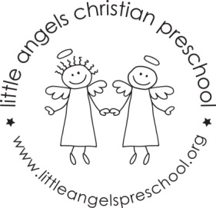
November 2021 Newsletter
Dear Parents,
The children have all settled into our classroom and we are really enjoying getting to know them. Special thanks to our room moms for making our Halloween/Fall party so much fun! We missed having you guys there but the children had fun and especially enjoyed the delicious snacks!
For the month of November our themes will be transportation, pets and of course Thanksgiving! On Monday November 1st and Tuesday 2nd we will have a school bus visit for our theme on transport. The children will get to explore the bus while it is parked outside. We will have a car wash, crinkle paper with animals and feathers in the sensory table. Our art projects will include vehicle stampers, painting with feathers, water colors and also making a hand cutout turkey. Our table top manipulative games include some vehicle puzzles, a pet sort and count, feed the animal toy and Mr. Potato head pieces.
We will be reading “I’m Your Bus”, “Good Boy Fergus”, “Biscuit is Thankful” as well as learning some new flannel board stories and singing “My Little Turkey”.
Reminder, there is no school on Friday November 5th Thanksgiving break is November 24th – 26th.

As the weather gets colder we will continue to go outside unless it is raining or too cold, please make sure your child’s outdoor coat is labeled with their name. Please put hats, gloves etc. into the sleeve of the coat. We are not able to look in each child’s backpack for these. Thanks!
God bless you and your family and have a blessed and safe Thanksgiving.
Martha Carroll and Maggie Killick

