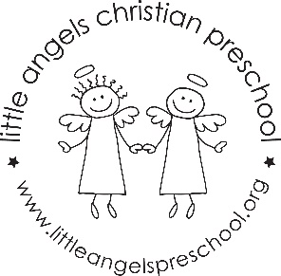
November 2021
Three-year-old class newsletter

It was great meeting with you all for fall conferences. Please remember that we are available to you for any questions or concerns throughout the year, not just at conference time.
It’s amazing how time flies by! It’s hard to believe that we are already into November! The month of November will be taking us into some fun themes. We will start with construction and then move into land transportation. The two weeks after that we will talk about Thanksgiving and then we will begin our Christmas theme – starting with the Gingerbread Man. Our dramatic play area will become a train station and we will be “making” Thanksgiving dinner in the house area. We will even have a stuffed turkey! In our art center we will explore things to paint with including toy cars and feathers. In the science area we will investigate real turkey feathers from Wisconsin turkeys and we will look at what kind of things wild turkeys eat.
We will be starting our writing table. Please be working with your child at home on writing their name and the proper grip of the writing instrument. We will continue meeting our Letter People (G, H, I and J) and learn the sign language to go along with it.
Please be sure to send your child with a warm coat, hat and mittens because we will continue going outside to enjoy this brisk November month. Also, It would help us A LOT if you would put your child’s mittens and hats in the sleeve of their coat OR on the top shelf of their cubby. Please check your child’s extra clothes to make sure that they have weather appropriate clothes.
Thank you for being extra aware of your child’s health and extra careful when you travel. Reminder – if you travel by plane you will need to self-isolate for the week after you return.
Reminders:
Friday, November 5 – No school
Wednesday, November 24 – Friday, November 26 – Closed for Thanksgiving.

Happy Thanksgiving!
Your Three-year-old teaching team: Sue Dreys and Anne Gierthy

