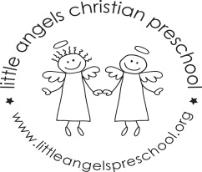
September 2021 2’s Newsletter

Dear Parents
Welcome, it is very exciting to start the new school year in person. We can’t wait to get to know the children and their different personalities. Reminder, on our first day (Tuesday and Wednesday) we will have class from 9am to 10.30am to help the children adjust.
Things will of course be a little different in the classroom, we will all be wearing masks and washing our hands more often. We have planned lots of activities and projects to make sure the children have fun and enjoy their time here.
During the month of September the children will be exploring the classroom and playground as they adjust to separating from their care givers and make new friends. Our themes will be “Welcome to preschool,” “Family and Where I Live,” “Friends” and “Colors,” we will be learning about red and yellow this week.
Please make sure that your child has diapers (if needed) and a change of clothes. Also, please label all clothes, jackets, coats etc. with your child’s name.
We look forward to a terrific year, we hope you can make it to our ice cream social on Thursday September 16th at 5.30pm and the fundraiser on September 24th. More details to follow! If you have any questions or concerns, please don’t hesitate to get in contact with us.
God bless you and your family,
Martha Carroll and Maggie Killick

