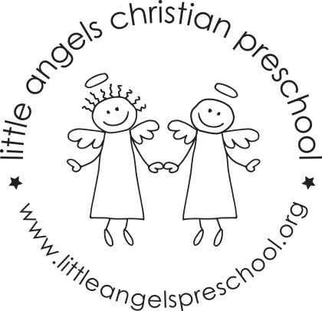

May 2021 Newsletter
Wow, this school year has just whizzed by, we can’t believe that it is May already!
It has been a great year, we have really enjoyed getting to know all of the children and we are so proud of how they adapted to the COVID restrictions!
During May, our themes will be flowers, The Three Little Pigs, The Three Bears and we will finish with kids choice week. During this week we will have some Christmas and other holiday themed table toys and we will sing “The Pumpkin on the Vine” and some other favorite songs and stories the children have especially enjoyed this year.
For art we will paint with real flowers and straw, decorate a bear shape and use stickers, crayons and markers. Our dramatic play area will be a flower shop, a pet vet and a grocery store. We will also have housekeeping with babies and strollers.
We will be reading “In My Garden,”, Biscuit Loves Mother’s Day”, “The Three Little Pigs”, “Goldilocks and The Three Bears” along with some of the children’s favorite stories, songs and flannel boards they have enjoyed this year.
We have a fun event planned for the last day of each class, more details to follow!
Thank you for sharing your children with us and have a great summer.

Martha Carroll and Maggie Killick

