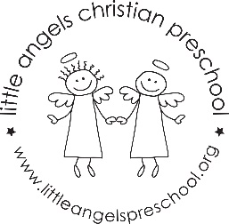 2’s April Newsletter

This month we will explore new themes and topics with your children. We will explore Rainbows, Our Earth and Bugs. We have new art activities, songs, stories and sensory activities to keep the children busy. We will also celebrate ALL children during Week of the Young Child. During this week we will have some special snacks and activities. We will learn a new prayer at snack time and continue to get some much-needed fresh air and sunshine during our large motor time. Please follow us on Shutterfly for up-to-date classroom information and fun photos during class.
Please do not hesitate to contact us if you have any questions or concerns.

Stay Safe!

Martha and Maggie

