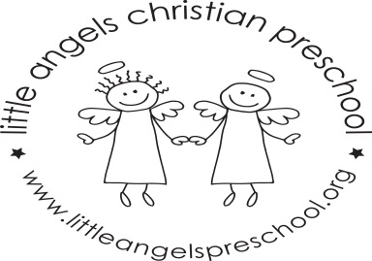
March Newsletter

Dear Parents,
Spring will be here soon, hopefully!!
During March our themes will be Pets, Construction, “St. Patrick’s Day” and Easter. We will have a pet vet, construction area, Easter baskets with plastic colorful eggs and housekeeping in our dramatic play area. For St Patrick’s Day we will have green table covers, napkins, plates etc.
For art we will be painting with feathers, using water colors and experimenting with mixing together blue and yellow paints. We have a wide variety of table toys including animal puzzles, play dough, feed the dog and bunny and some matching games. We will sing “Johnny Hammers with One Hammer”, “The Itsy Bitsy Spider” and enjoy some fun flannel board stories and books.
Conferences will be via Zoom on Thursday April 1st.
There is no school on Friday March 19th and for the week of March 22nd due to Spring Break. We hope you have a wonderful and safe break wherever you are spending it. As always, please do not hesitate to call, email or stop by with any questions or concerns.
Martha Carroll and Maggie Killick

