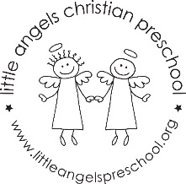Fantastic Fours!
March, 2021

Dear Parents,

Spring is on the horizon and warmer weather is sure to come! We have spent many days indoors, and we are all looking forward to playing outside more. Thank you for sending appropriate outdoor clothing to school.

Our Jolly Phonics sounds in March will be “N, V, W, and X”. Our morning prayer will be the “Creed” which we say with Father Jesse during our chapel time. The Fruit of the Spirit in March is “Faithfulness” symbolized with a banana.

During the month of March, our dramatic play area will be transformed into a rainforest! Complete with a jeep and rain falling from the clouds! We will watch the growth of a “leprechaun cup” with green grass.

Spring break will begin on Friday, March 19. School will resume on Monday, March 29. Parent/Teacher conferences will be held on Thursday, April 1. Conference sign up information will be announced via Shutterfly later in the month.

Mrs Clarke, Mrs Gierthy and Mrs Fischel

Important Dates in March:
Friday, March 19–Sunday, March28: Spring break
Monday, March29: Classes resume
Thursday, April 1: No Class- Conferences
Friday, April 2: No School

