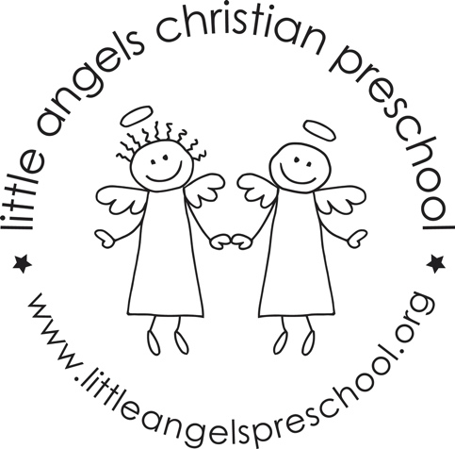
February 2021
Three-year-old class

February is here and this month we have some fun themes planned. We start the month exploring Groundhog’s Day and shadows, then Valentine’s Day and the end of the month we will start exploring the five senses starting with Touch.

We will introduce our letter people M, N, O and P this month. We will focus on writing capital letters and the children recognizing and starting to write their first names (starting with a capital and then lower-case letters). We have added a Kindness wall to our room and love to catch students who demonstrate kindness to one another.

Reminder:
February 10,11- Class Valentine’s parties
Students will exchange valentines. Fill out the “From” section, but leave the “TO” blank.

February 12, 15- No School, please let us know if you are traveling.

Be sure to keep checking our daily journal entries and pictures on Shutterfly to see what’s happening in our room. We are busy and having fun!

Stay warm and safe!

Your Threes teachers – Sue Dreys and Laura Loppnow

