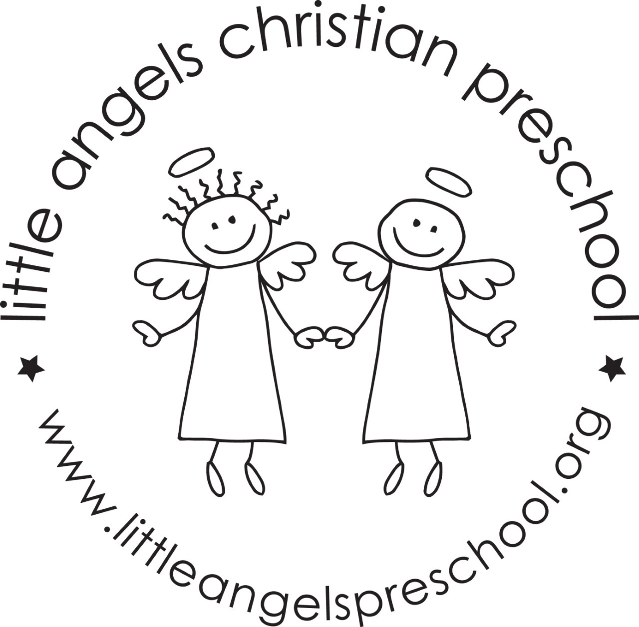

February 2021
Wow! We cannot believe we are already in February! Our class has grown so much. This month, our jolly phonics sounds will be “R, K, A, and M”. The dramatic play area will transform into a Valentine’s House, followed by an arcade (complete with prizes of course) and then a music room.
During the month, we will be decorating the room in shades of red, counting and sorting hearts and singing our songs about ‘Love’. Our Valentine’s Party will be on Thursday February 11. Please do not fill out the ‘To’ section, only fill in the ‘From’ section on the Valentines that your child sends in for the party. We will distribute during class time.
Our art appreciation in February will be about Paul Cezanne. We will continue to review letter sounds learned in previous months while combining with new sounds!
Thank you for sharing your child with us!
Mrs Clarke, Mrs Gierthy, and Mrs Fischel
Important Dates:
2/11 Valentines Party
2/12 & 2/14 No school

