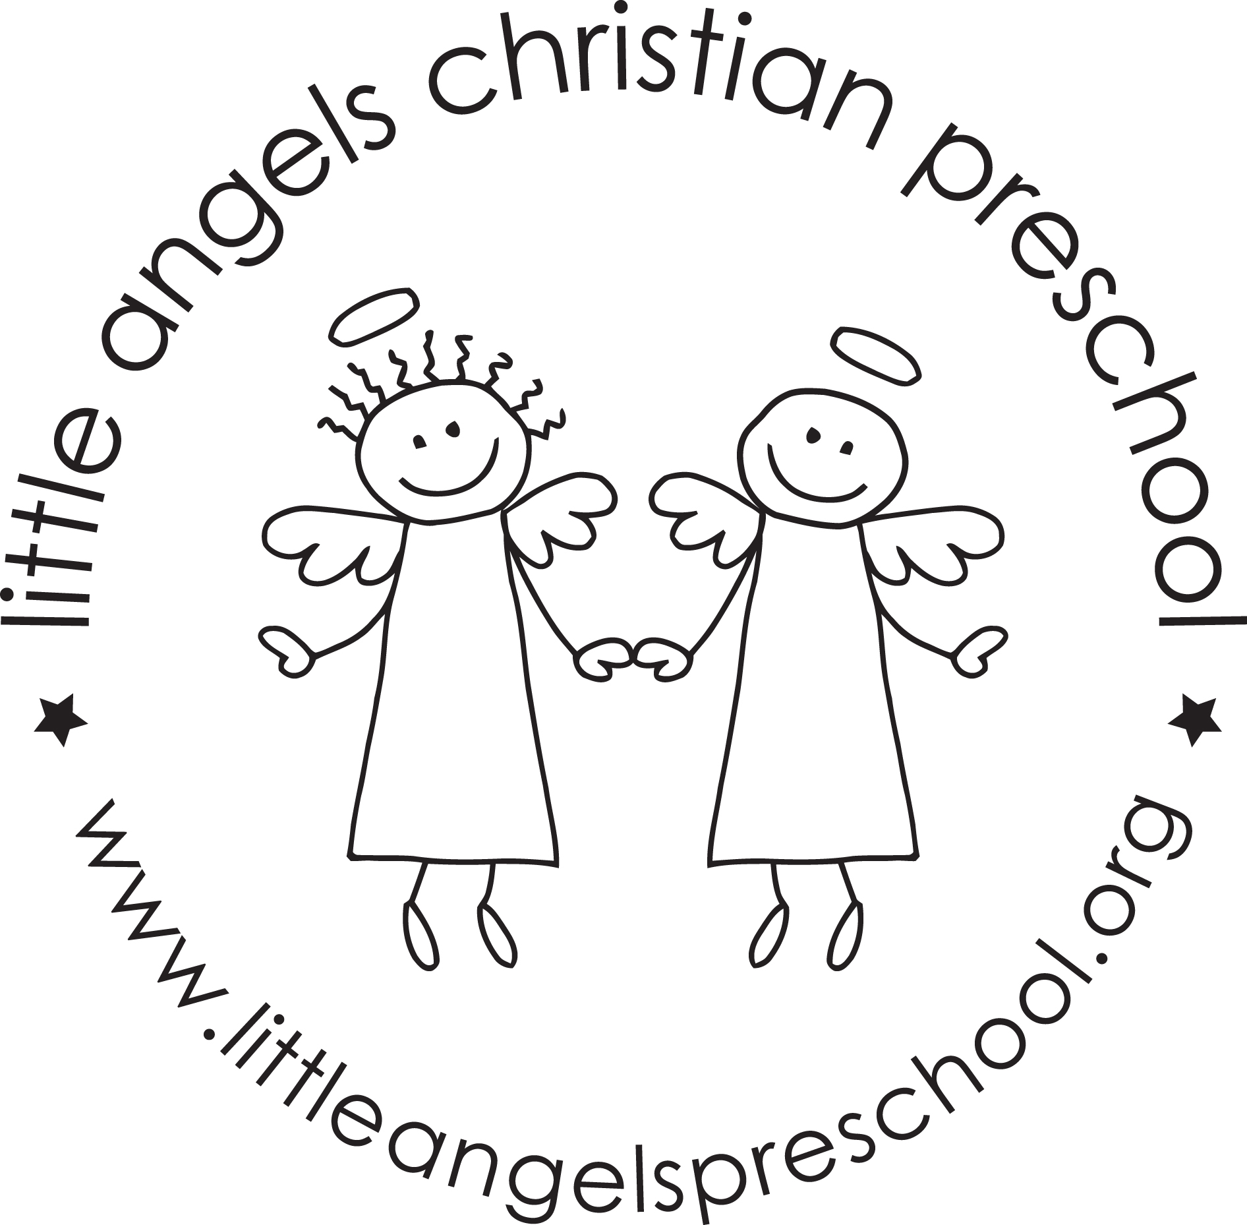Threes Newsletter
January 2021!
We hope everyone had a fantastic and healthy Christmas break. Thank you all for the wonderful and thoughtful gifts. We appreciate them all so much! We can hardly believe it’s the month of January and 2021 is here! This month our themes will be about snow and forest animals.
Mark your calendars for Monday, January 18. We will be closed for MLK day.
The next couple of weeks will be very busy in our classroom. We will be working more on writing our names. We will also be cutting the photos off of the check in cards and the children will have to find their name without the photo.
We will be starting our Kindness “board” this month as well. We will be watching the children and looking to see who is being kind. When we catch them being kind we will fill out a kindness circle and add it to the wall!
We will continue to go out to the playground as weather permits. Be sure to remember hats, mittens, boots and snow pants. These can be left at school (if you have an extra set) OR you can put them in a bag and bring them back and forth to school. IF THE TEMPERATURE (WIND CHILL FACTORED IN) IS BELOW 20, WE WILL NOT GO OUTSIDE. We will also be working with the children on getting their own coats on and zipping them as well!
Thank you for being mindful of your child’s health and keeping them home when necessary. We all appreciate it!
We are always available if you have any questions, compliments or concerns!!
Your Three-year-old teaching team: Sue Dreys and Laura Loppnow

