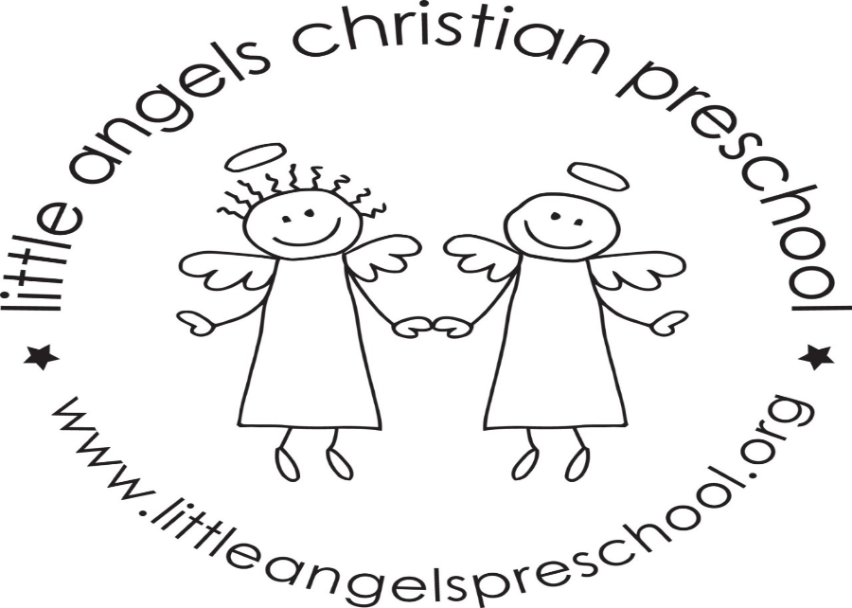
Welcome back! We hope everyone had a fantastic Christmas Break, we sure did miss everyone. We are excited to continue our learning! Our jolly phonics letters of the week are as follows:
Jan. 11 – letter D
Jan. 18 – letter P
Jan. 25 – letter B
We will focus on the sounds and practice writing the new letters! In celebration of letter D we will be learning about dinosaurs! On Wednesday Jan. 20 we will have PAJAMA DAY! Everyone’s favorite! We will stay in to play in the undercroft that day regardless of the weather.
Reminder – no school Monday Jan. 18. Enjoy the long weekend.
Also, lunch pals and enrichment are offered in our classroom Mon, Tues, and Wed each day school is in session.
Remember to pack warm winter gear (snowpants included) if the wind chill is above 20 degrees we will try to go outside for fresh air.
We are always available if you have any questions!
Thanks,
Mrs Clarke, Mrs Fishel, Mrs Gierthy

