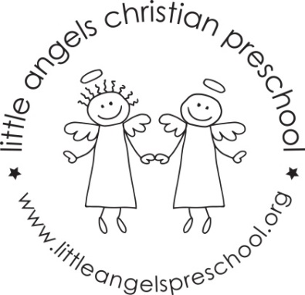

Newsletter January 2021

Happy New Year!

Dear Parents,

Welcome back, we hope you had a safe and wonderful Christmas. Thank you all so much for the generous and thoughtful gifts, we really appreciate them.

For January we have some fun activities planned for the children, our themes will be, snow and snowmen, penguins and Arctic animals. We finish the month with zoo animals.

Our art activities will include painting with brushes, stickers, making a collage, drawing with chalk and painting with frozen paints. We will build with a variety of different blocks and have shaving cream, snow and cotton balls with animals in our sensory trays. To further develop our fine motor skills we will work with play dough, manipulative toys and puzzles.

Our dramatic play area will include a grocery store, doctor’s office and cameras and phones.

Reminder, please put hats, gloves etc. into the sleeve of your child’s coat. Thanks!

**Reminder: No school Monday Jan 18th – Martin Luther King Day**

Martha Carroll and Maggie Killick