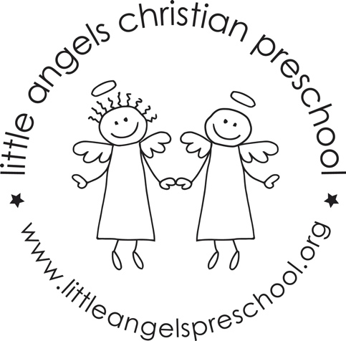
December 2020
Three-year-old class

2020 is drawing to a close and we are so happy to be in person learning still here at Little Angels. Thank you for keeping us aware of any travel plans and keeping your child home if they are not feeling well. We have been working hard to keep our learning space clean and safe. The kids are doing a great job with their masks and washing their hands many times during our school day.

This month we are planning lots of Christmas themed fun. We will explore gingerbread activities, Christmas songs, the Nativity, Santa, winter snow and much more. Please let us know if there are any special holiday traditions your family celebrates including cultural foods.

We will continue our writing table. Please be working with your child at home on writing their name and the proper grip of the writing instrument. We will continue meeting our Letter People (H, I and J) and learn the sign language to go along with it.

Please be sure to send your child with a warm coat, hat, boots and mittens because we will continue going outside if it is 20 degrees and above with wind chill. Also, it would help us A LOT if you would put your child’s mittens and hats in the sleeve of their coat or on the top shelf of their cubby. Please check your child’s extra clothes to make sure that they are weather appropriate.

Reminder:
December 23-January 6 - No School, Winter Break

We wish you a very merry Christmas and Happy New Year!
Your Threes teaching team – Sue Dreys and Laura Loppnow

