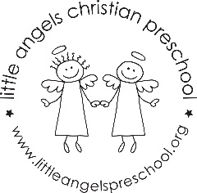
2’s December Newsletter

What a wonderful time of year to have a toddler! We are so excited to share some Christmas joy with them. This month we will begin with our theme of SHAPES and finish with CHRISTMAS. We will learn some holiday songs and introduce our musical instruments. For art we have new painting experiences, collage materials and stampers. Our dramatic play will start the month as an ice cream shop but then we will decorate for Christmas with our classroom tree and our Nativity set. We will continue to go outdoors as long as it is not too wet and cold. We will have a small holiday party before we end for our break. Again, it won’t be the same without parents and grandparents but we will send some pictures. Hope you all have a wonderful Christmas Season.

Martha and Maggie

