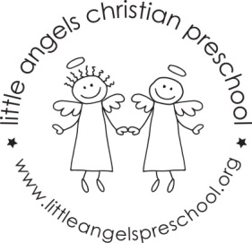
November 2020 Newsletter
Dear Parents,
The children have all settled into our classroom and we are really enjoying getting to know them. We had lots of fun at our Halloween/Fall party and parade last week. We missed having you guys there and special thanks to the room moms for making our tables look so festive and especially for the snacks!
For the month of November our themes will be leaves, fall colors and of course Thanksgiving! We will have leaves and feathers in the sensory table and for art we will be painting a leaf, making leaf prints with cookie cutters, painting with feathers and kitchen utensils and also making a hand cutout turkey. Our table top manipulative games include some fall color puzzles, shape sorter, stacking pegs, feather sort and count, feed the animal toy and Mr. potato head pieces.
We will be reading “The Leaves Are Falling One by One”, “Red Leaf, Yellow Leaf”, “Biscuit is Thankful” as well as learning some new flannel board stories and singing “My Little Turkey”.
Thanksgiving break is November 25th – 27th.
As the weather gets colder we will continue to go outside unless it is raining or too cold, please make sure your child’s outdoor coat is labeled with their name. Please put hats, gloves etc. into the sleeve of the coat. We are not able to look in each child’s backpack for these. Thanks!
God bless you and your family and have a blessed and safe Thanksgiving.
Martha Carroll and Maggie Killick

