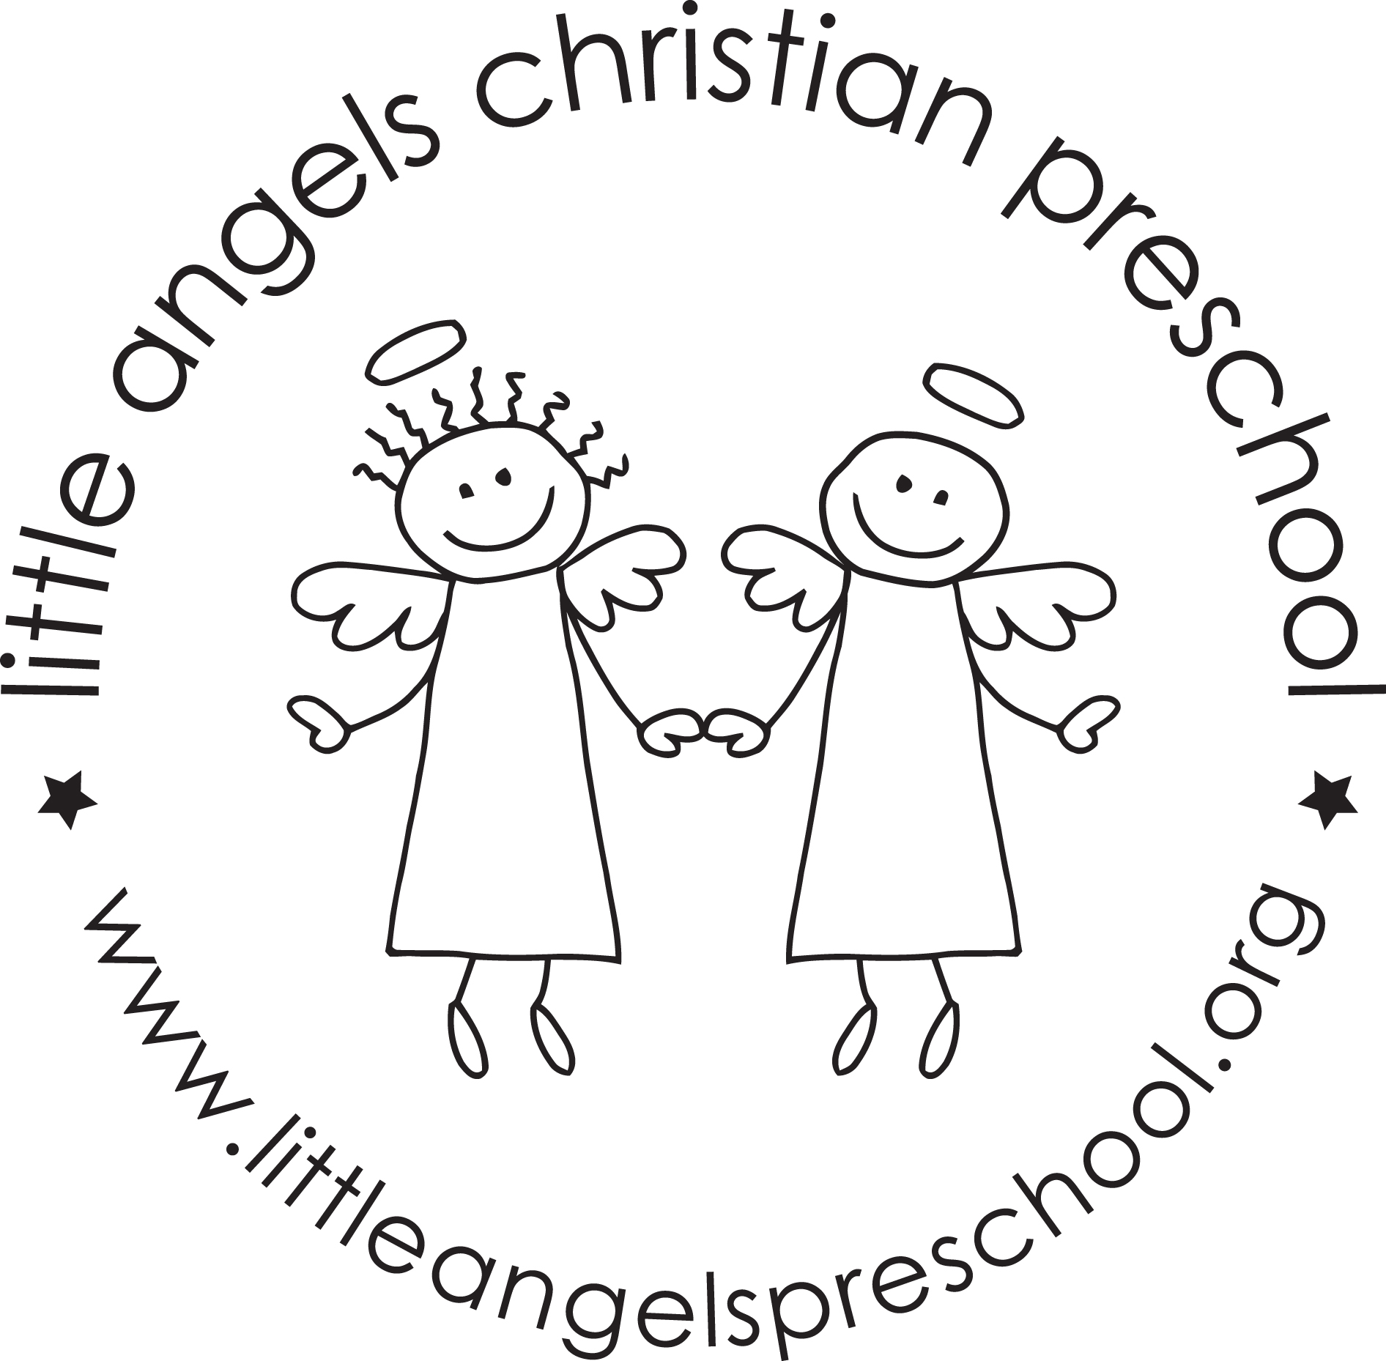November 2020
Three-year-old class

It was great meeting with you via zoom for our fall conferences this year! Please remember that we are available to you for any questions or concerns throughout the year, not just at conference time.

It’s amazing how time flies by! It’s hard to believe that we are already into November! The month of November will be taking us into some fun themes. We will start with land transportation and then move into construction. The last two weeks of November we will be talking about Thanksgiving. Our dramatic play area will become a train station and we will be “making” Thanksgiving dinner for the last two weeks. We will even have a stuffed turkey! In our art center we will explore different things to paint with including toy cars and feathers. In the science area we will investigate real turkey feathers from Wisconsin turkeys and we will look at what kind of things wild turkeys eat.

We have started our writing table. Please be working with your child at home on writing their name and the proper grip of the writing instrument. We will continue meeting our Letter People (E, F, G and H) and learn the sign language to go along with it.

Please be sure to send your child with a warm coat, hat and mittens because we will continue going outside to enjoy this brisk November month. Also, it would help us A LOT if you would put your child’s mittens and hats in the sleeve of their coat or on the top shelf of their cubby. Please check your child’s extra clothes to make sure that they have weather appropriate clothes.

Thank you for being extra aware of your child’s health and extra careful about where you travel. We have NOT had a positive case of Covid-19 and we hope to keep it that way throughout the rest of this year!

Reminders:
Tuesday, November 3 – No school (Election Day)
November 9 – 15 – On line Anderson Book Fair
Wednesday – Friday, November 25 – 27 – Closed for Thanksgiving

Happy Thanksgiving
Your Threes teaching team – Sue Dreys and Laura Loppnow

