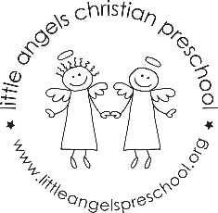 2’s OCTOBER NEWSLETTER

We are off to a great start for the 2020-21 school year. We are so happy to see the children adjusting to their new teachers, classmates and routines. During the month of October our themes will be “APPLES”, “FARM” “PUMPKINS” and “HALLOWEEN”. We will explore new art activities, sensory experiences and add some group games during circle time. We will continue to enjoy both indoor large motor time and some nice fresh air on the playground. We hope your child is having as much fun at school as we are. If you ever have any questions or concerns please do not hesitate to send an email or give us a call. We look forward to our Fall Zoom conference on Thursday October 15th. Our class parties are October 28th and 29th. Your child is welcome to wear their costume to school on those days. Thank you in advance to those parents who helped plan. We will do our best to make it a great celebration and send some fun pictures so you can see the children in action!
Thanks for sharing your little one with us!
Martha Carroll and Maggie Killick

