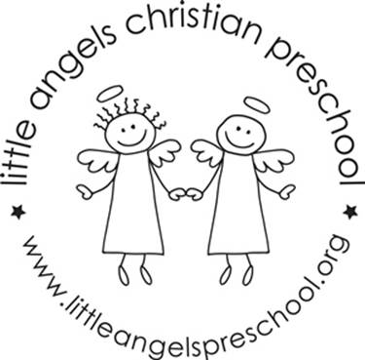
October 2020
Three-year old class newsletter

It’s fall and we are off to a great start to the school year. We will be welcoming a few new students starting this month in both classes and we will be getting to know each other as well as classroom rules and routines.

During the month of October we will explore the following themes: our families, apples, pumpkins and Halloween. We will have parent/teacher conferences virtually on Thursday October 15 during school hours. Watch for the signup sheet coming soon. Conferences will be a 10 minute conversation focusing on the social emotional growth of your child since the start of school. The end of the month brings Halloween and our parade and parties. We will have outdoor all school costume parades around our building at 9:25am on the 28th and 29th. Our classroom parties will follow, but unfortunately parents will not be allowed inside for the parties this year. We will be looking for volunteers to donate party items and plan activities for our class parties.

Dates to remember:

October 15- Virtual parent teacher conferences
October 16- No School
October 28 & 29- Class Halloween parties and all school outdoor parades

