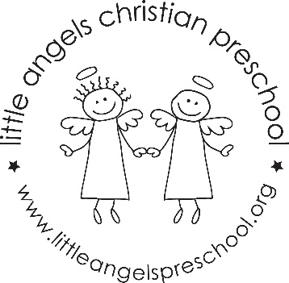
October 2020
Fantastic 4’s Newsletter
Mrs. Clarke, Mrs. Gierthy, and Mrs. Fischel

The Fantastic 4’s had a wonderful start to the new school year. We have quickly learned the class routine and jobs at circle time. We are very excited to welcome 2 more students to the class on October 5.
On October 1 we will have a visit from a Therapy Pony from the Say Yes to Kindness Program. The theme will be “Kindness Is My Superpower.”
The Jolly phonics sounds for the month will be E (as in egg), H, T, and I (as in inch). Our “Fruit of the Spirit” will be “Joy” symbolized by a pear. Our Dramatic Play Area will change from the Farmers Market to a Birthday Party, a Transportation Center and then a Halloween House. We will have our first Art Appreciation Activity featuring Jackson Pollock with drip-fling painting. We will be conducting some science experiments with eggs, pumpkins, and outdoor nature items. Our math skills will be enhanced with balance scales, number games and puzzles, and measuring. During play and table times, our small motor skills, social, and cognitive skills are being utilized with different activities and games put out each day. The daily updates sent via Shutterfly will outline what those activities have been.
We look forward to meeting with you on Thursday, October 15 to discuss your child’s social-emotional adjustment to the 4’s class. This is a great time to go over any thoughts, concerns or questions you may have. Of course, we are always available before or after class if you need to talk to us.
Important Dates:
Thursday, October 15: No Class/ Parent-Teacher Conference
Friday, October 16: No School
Halloween Party Date to be announced. Watch your email for information.

