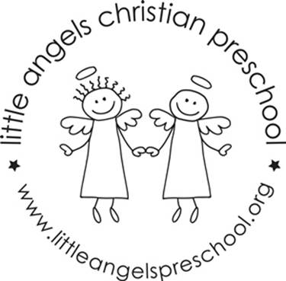
September 2020
Three-year old class newsletter

Welcome to the Little Angels three-year old class! We are excited about the school year and can't wait to get to know you and your child. We have been busy preparing the classroom and planning fun learning activities.

During the month of September we will spend time getting to know each other, our new room and a few new expectations. We will talk with the children about their unique qualities and their family structure within our theme “All about me”. We will explore our emotions and talk about the diversity of our families. At the end of the month our theme will be “Friends”. We will make a friendship snack and have fun table games using pictures of the children.

Each month you will be able to go onto our website to read our classroom newsletter. We will also be posting a parent letter from our Creative Curriculum materials (which is what we use to develop our themes and activities). These parent letters will explain the benefits of each area of our classroom. September is the only month that you will receive this newsletter by email! Please check out our website at the beginning of each month. You can go to www.littleangelspreschool.org and select “enrolled families”, “class pages” and then pick the Threes Class that your child is enrolled in.

Please make sure that your child has two weather appropriate changes of clothes in ziplock baggies and diapers/pull-ups if still needed. Also, please make sure that all items are labeled with your child's name.

We have an email address for our classroom. We will only check it before and after class. So, if you have something that you need us to know right away, you should call the school office: (847)381-5490. If it's something that does not need immediate attention, please feel free to use our classroom email. The address is: threes@littleangelspreschool.org

Please be watching your email for an invite to our class Shutterfly account. This is where we will post daily information about our day as well as important reminders. We will also post pictures of the children engaging in play, doing art, using our table toys, etc..

It has been a long 5 ½ months without the beautiful sounds of children in our school and we are looking forward to being with you again and having a great year!

Your three-year old teachers: Sue Dreys and Laura Loppnow
**Anne Gierthy has taken a leave to be with her children until District 220 goes back to in person school.

