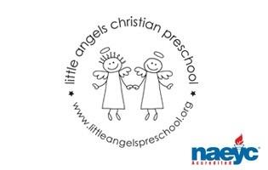
March 2020
Toddler Newsletter – Loppnow/Williams/Katzbeck

Hello, Toddler Parents! We are hoping to head into spring this month with more outdoor time for our toddlers. Assume we will go out daily and pack the appropriate attire according to the weather. March fun will kick off with learning and playing opportunities exploring our five senses, St. Patrick’s Day, the color green and spring.
Please let us know if your toddler is starting to use the potty at home. We do have a toddler sized toilet in our changing room in our classroom.

We will send home a write up in April based on our observations of your toddlers in various areas of development. You can also sign up for a ten minute conference where we can talk about our observations and any concerns/questions you may have. Sign ups will be out this month for April’s conference. Let us know if you can’t make the day and would like to reschedule.
Reminder:
Spring Break- No school March 20-29
We will have Parent/Teacher conferences on April 9 , sign up sheet coming soon.

Your Toddler Teachers,

Laura Loppnow, Lynda Katzbeck and Kelly Williams

