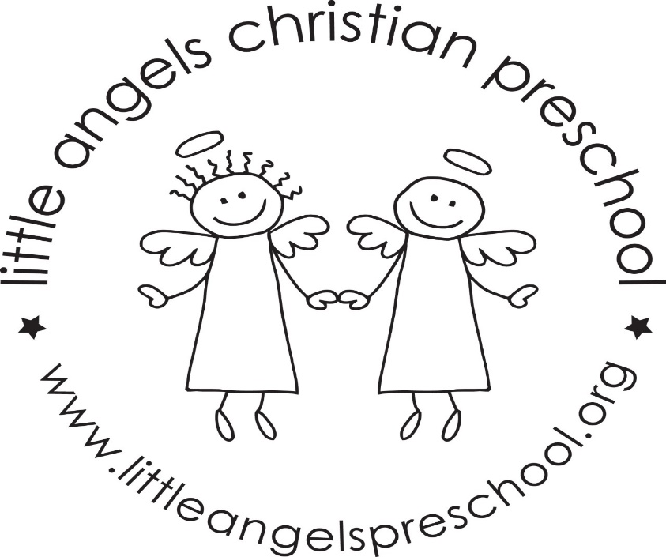

March 2020
This month we will be busy learning about the senses (taste, touch, smell, hearing and seeing) and St Patrick’s Day! Lots of fun activities with our themes.
Reminder as the weather gets warmer (and then probably cooler again) to send your child with the proper outdoor clothing! We hope to go outside to play more often as the playground has defrosted.
Spring Break begins on March 20, and school will begin again on March 30. Enjoy the time off! Safe travels to everyone also.
Please let us know if you will not be available to conference on April 9. We will be offering other times before and after school. Also mark your calendars for Thursday April 16, it’s the Little Angels Family event.
Thank you for sharing your child with us, and if you ever have any questions we are always available!
Mrs Dreys & Mrs Gierthy

