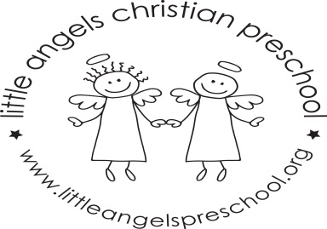
March Newsletter

Dear Parents,
Spring will be here soon, hopefully!!
During March our themes will be Bears, Spring, “St. Patrick’s Day” and Easter. We will have a flower shop, grocery store and housekeeping in our dramatic play area. For St Patrick’s Day we will have green table covers, napkins, plates etc.
For art we will be using stickers, painting with bear cookie cutters and water colors and experimenting with mixing together blue and yellow paints. We have a wide variety of table toys including bear puzzles, play dough, feed the bunny and matching games. We will sing “Teddy Bear, Teddy Bear”, “The Itsy Bitsy Spider” and enjoy some fun flannel board stories. The children also enjoy their time with Mrs. Oehler during our music class each week.
There is no school on Friday March 20th and for the week of March 23rd due to Spring Break. We hope you have a wonderful and blessed break wherever you are spending it. As always, please do not hesitate to call, email or stop by with any questions or concerns.
Martha Carroll and Maggie Killick

