Three year old class 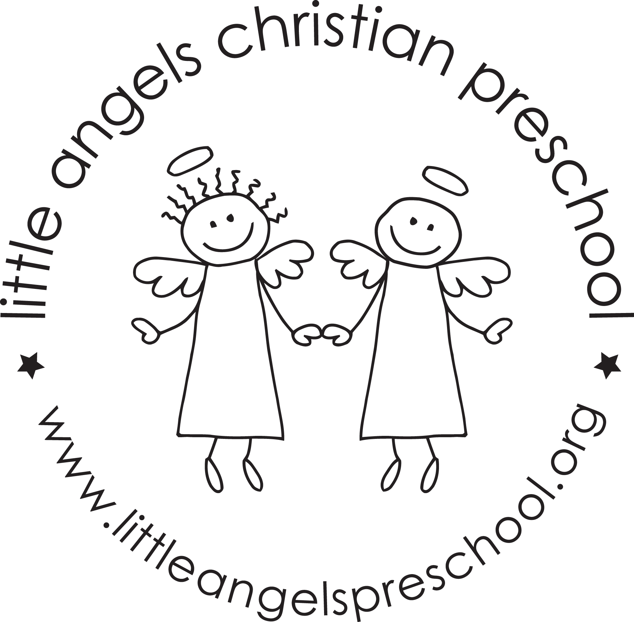February 2020

We will be making some big changes in the month of February! The children will be able to pour their own water refills at snack time. We will also introduce “writing” boxes in 4 different areas of the classroom. The children have been doing a great job finding their names WITHOUT their picture on it.
The month of February is sure to be a fun one! We have many new and interesting activities planned for the children. We will begin the month talking about groundhogs and will focus on dark, light and shadows. We will have a tent and tunnel for the children to burrow into. They will have flashlights because it’s so dark underground. We will use a light table and play a game in the dark using flashlights.
We will also talk about Valentine’s day. We have many heart games planned. We will even get to listen to our own hearts with a real stethoscope.
We will start talking about the five senses theme. We will also take this into March. We will use the SMART board to watch educational videos about our five senses.
We will be ending the month with our BEACH theme and will have a beach day where the children will come to school in beach attire. More information will come about this soon!
Please remember that we will go outside if the “feels like” temperature is above 20 degrees. It would be helpful if your child’s hat and mittens were on the cubby shelf or in the sleeve of the coat.
We will be helping the children pass out valentines to their friends BEFORE our class party. So, please bring them in to the room at drop off. Also, please DO NOT fill out the “to” part of the valentine….only the “from” part.
Valentines parties will be on Tuesday, February 11 and Wednesday, February 12.
We will be closed on Friday, February 14 and Monday, February 17
Your Threes teaching team: Sue Dreys and Anne Gierthy

