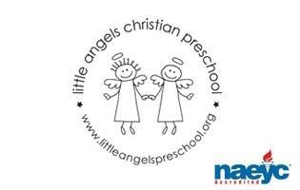
September 2019
Toddler Newsletter – Loppnow/Katzbeck/Williams

Welcome to Little Angels Toddler Program. We are very excited about the new school year and getting to know your child. This year will bring so much growth, development, learning and fun! This year Mrs. Loppnow and Mrs. Katzbeck will be teaching the Monday, Wednesday and Friday Toddlers. Mrs. Loppnow and Mrs. Williams will be teaching our Tuesday Thursday Toddlers. We are very excited to have Mrs. Williams this year! She is a Barrington mom of six and has a degree in Special Education.
During the month of September we will focus on getting acquainted with your children, their personalities, and what sparks their interest. Our goal is to have them get acclimated with the daily routine and get comfortable with their teachers. We have many areas in the classroom for your little ones to explore. There is dramatic play, vehicles, dress up, babies and doll houses, small and large blocks, fine motor work manipulatives, an art easel with varied art materials, sensory table where they can explore wet and dry materials, table toys, puzzles, science exploration, nature trays and a library area. We will also have weekly themes with books, songs, toys and activities that relate. Our themes for September include: Welcome to School, Getting to Know You, Families and Apples.
Whenever the weather permits we will enjoy stroller rides and our outdoor playground where there is a sandbox, climber with tunnel and slides, balls and small trikes. We also have an indoor large motor room for days where the weather just isn’t suitable for going out to play.
We have an email for our classroom that will be checked before and after class. You may reach us via email at toddlers@littleangelspreschool.org
Don’t hesitate to contact us! If you need immediate assistance during class hours please call the preschool office at: (847) 381-5490.
We are looking forward to a school year filled with fun and learning for our “littlest angels!”
Your Toddler Team,
Mrs. Laura Loppnow, Mrs. Lynda Katzbeck and Mrs. Kelly Williams
Important dates: Tuesday and Wednesday September 3,4 First day of class 9-10:30am. Blessing of children in the sanctuary 9am.
Thursday, September 12 - Ice Cream Social 5:30 - 6:30 pm
Saturday, September 28 Fall Fundraiser Barrington Hills Country Club (Adults only)

