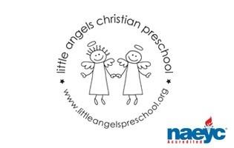

January 2020

Toddler Newsletter – Loppnow/Williams/Katzbeck

We hope you had a wonderful holiday break and enjoyed lots of family time! We want to thank you for all of your generous gifts! It made us feel very special! We are excited to have the children back at school, and we look forward to a great 2020!

January will be a fun month as we learn about polar bears, penguins, snow and trains. We’re planning lots of fun activities, music, art, sensory and fine motor work that involve all of these themes.

Reminders:

- No school on January 20th

- Please send in mittens and hats everyday. We love to get our walks and play outside when the weather cooperates. Also boots and snowpants if we do get snow.

- Diapers...if you can send 4 in your child’s backpack, that would be great.

We look forward to a great January with our class! Thank you for sharing your children with us. They are such a joy and blessing!

Your Toddler Teachers,

Mrs. Laura Loppnow, Mrs. Katzbeck and Mrs. Williams

