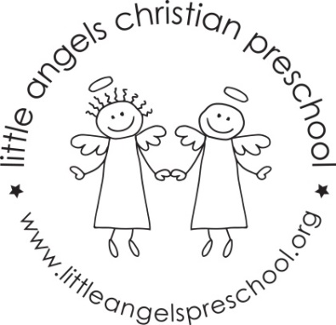

Newsletter January 2020
Dear Parents,
Welcome back and Happy New Year, we hope you had a blessed and wonderful Christmas. Thank you all so much for the generous gifts, we really appreciate them.
We have planned some new and exciting activities for January. Our themes will be Gingerbread man, winter with snow and penguins and shapes.
Our art activities will include painting with brushes, using glue sticks to make a collage, drawing with chalk and painting with frozen paints. We will build with a variety of different blocks and have oatmeal, frozen water and snow sensory table. To develop our fine motor skills we will work with play dough, manipulative toys and puzzles.
Our dramatic play area will include a doctor’s office, cameras and phones and a pizza parlor.
Mrs Oehler our school music teacher will visit us once a week beginning in January for our music class, we are very excited about this! Father Jesse will also visit for our Chapel time.
Reminder, please put hats, gloves etc. into the sleeve of your child’s coat. Thanks!
Reminder: No school Monday Jan 20th – Martin Luther King Day

Martha Carroll and Maggie Killick

