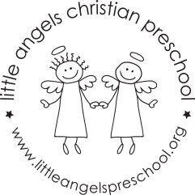
Dear families,
Art is an important part of our curriculum. Every day, children find a variety of art materials available on our shelves. Drawing, painting, gluing, molding and constructing are not only enjoyable but also provide important opportunities for learning. Children express original ideas and feelings, improve their coordination, learn to recognize colors and textures, and develop creativity an pride in their accomplishments by exploring and using art materials.
When children are engaged in art activities, we talk with them about what they are doing and ask questions that encourage them to think about their ideas and express feelings.
We are just as interested in the creative process as we are in what children make. We say things that will encourage children to be creative and confident, such as:
- Tell me about your picture instead of Is that a house you made?
- It looks like the playdough is sticking to your fingers. What could we do to make it less sticky?
What you can do at home
Art is a very easy way to bring your child’s school life into your home. Children love to bring home their art products to share with the most important people in their lives. Take time to talk with your child. Here are some things you might say:
- Tell me about your picture.
- How did you decide which colors to use?
- What do you like best about it?
- Should we hang it up in a special place so we can all enjoy your work?
You can help your child appreciate art right in your home. When you look at books together, talk about the illustrations with your child. Discuss the art on the walls in your home.
Art is something your child can do at home in almost any room. You might designate a drawer in the kitchen or living room as an art drawer, or use a bookshelf or sturdy cardboard box. In this space include crayons, markers, paper, a pair of child-sized, blunt-edged scissors, glue and a separate box for collage materials. A child’s mind is much more creative and artistic than any coloring book allows.

Duplicated with permission from The Creative Curriculum for Preschool.

