Little Angels 2’s…

Happy Holidays! 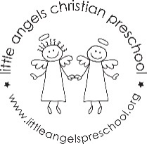
This month our theme is Christmas. We will be introducing new process art projects and sensory activities for the children to enjoy. Our table activities will be focused on matching, sorting and other fine motor skills. At group time we have new games and new flannel board stories and songs. It will definitely be a busy month and we look forward to spending this magical time of year with your children.
December 18th and 19th are the Holiday parties at 11:00 am in the classroom. All are welcome to attend.
Please let us know at any time if you have questions or concerns.

Martha Carroll and Maggie Killick

