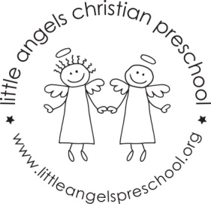
November newsletter
Dear Parents,
The children have settled well into our classroom and we are really enjoying getting to know them. We had lots of fun at our first party last week, thank you for making them so enjoyable for the children.
For the month of November our themes will be leaves, community helpers and of course Thanksgiving! We will have leaves, feathers and soapy water in the sensory table and for art we will be painting with leaf cookie cutters painting with feathers and kitchen utensils and decorating a turkey shape.
We will be singing “Good Morning To You” a community helpers song, “My Little Turkey”, and “Thank You God” as well as learning some new flannel board stories and reading some new library books.
We will be having a special all school Thanksgiving snack on Monday and Tuesday November 25th and 26th. This is always a fun event.
Reminder: There is no school Friday November 8th– In Service day.
Thanksgiving break is November 27th – 29th.
As the weather gets colder we will continue to go outside unless it is raining or too cold, please make sure your child’s outdoor coat is labeled with their name. Please put hats, gloves etc. into the sleeve of the coat. We are not able to look in each child’s backpack for these. Thanks!
God bless you and your family and have a blessed Thanksgiving.
Martha Carroll and Maggie Killick

