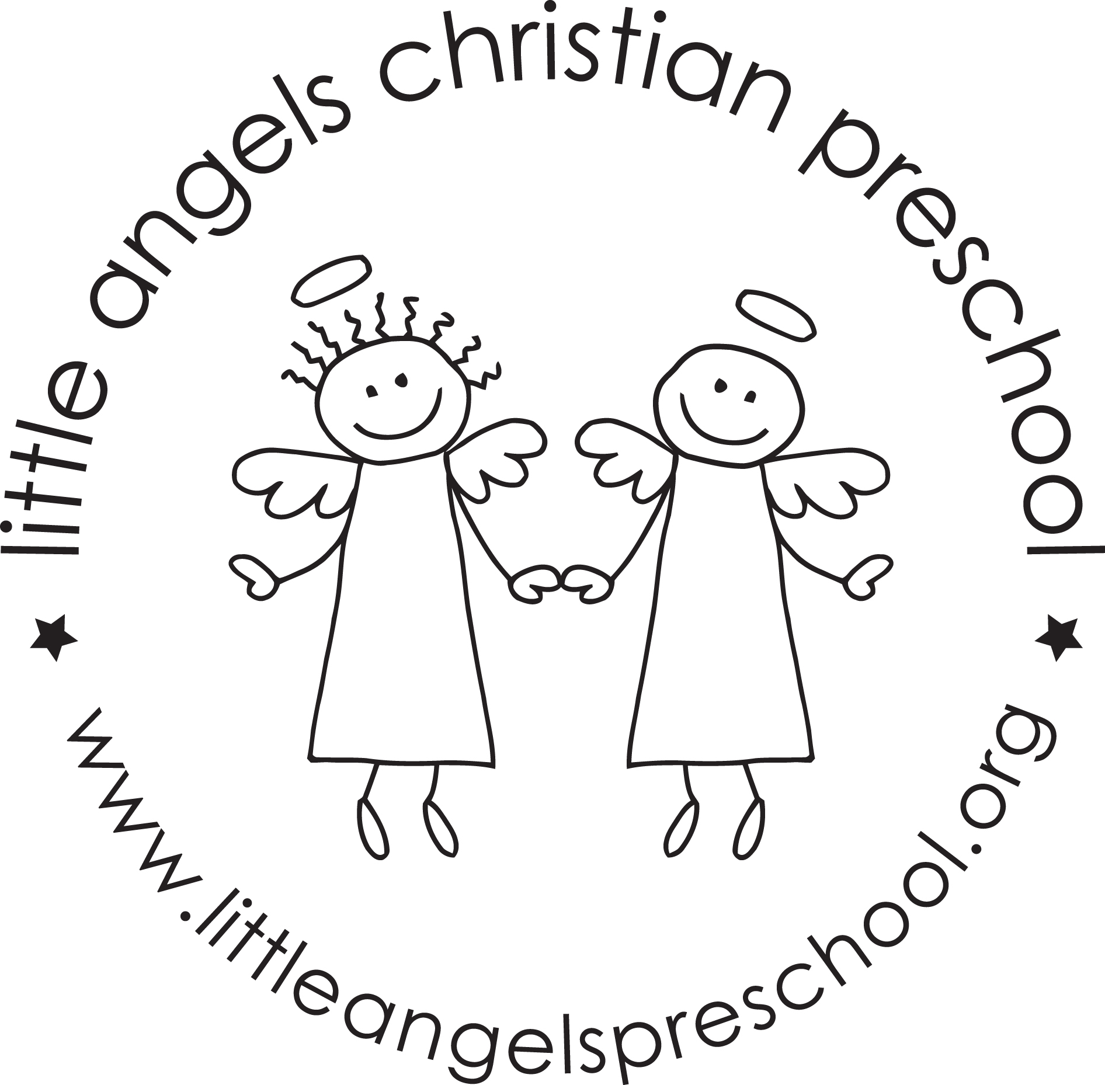November 2019
Three-year old newsletter

We can hardly believe it’s already November! The children have been forming some wonderful relationships and becoming more independent every day. Thank you to everyone that came to conferences. We are always available if you ever have a thought or concern that you would like to share with us.
Our themes this month are: Land transportation, Thanksgiving and construction. We will also be adding our writing table this month! We will encourage all of the children to take part in this. We will also continue meeting our weekly Letter Person!
We will try to go outside as weather permits. Please remember hats and mittens as the weather grows colder.
We will talk a lot about Thanksgiving and what the children are thankful for. We will look at real turkey feathers and investigate what kinds of things turkeys eat.
As usual we are always available if you have any questions!

Your Threes teaching team – Sue Dreys and Anne Gierthy

