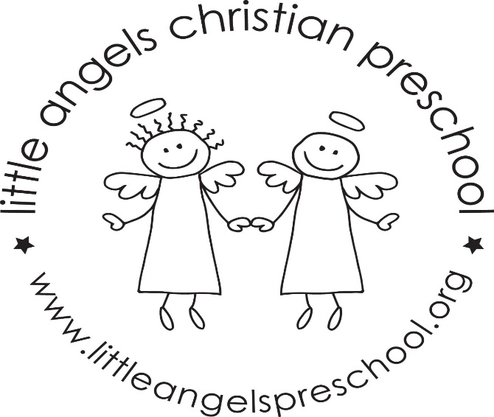

October Newsletter
The 3’s Classroom
It is officially fall, as indicated by the calendar and the weather! It’s an exciting time in our classroom! We are getting to know the children and their individual personalities, and they are getting to know us and each other. The classroom rules and routines are moving full steam ahead!
Apples, Pumpkins/Fall and Halloween/Harvest are among our themes this month. We will continue with the letter people also. Hopefully your children are coming home and letting you know all about the letter people and the letter of the week in sign language. Mystery readers have begun, the kids love figuring out who the reader will be. We still have slots open if you haven’t been able to sign up yet! Let us know. Be sure to sign up for conferences if you haven’t already! Send a jacket if it’s chilly outside, we love playing outside when the weather permits. If you have questions we are always available! We are looking forward to the classroom Halloween parties at the end of the month! All are welcome to attend.
Reminders:
October 17/18 - No School (Conferences 10/17)

