Little Angels 2’s…
Welcome to October! 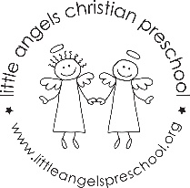
We are so happy that the children have settled into the preschool routine and seem to be enjoying their classmates and teachers. This month our themes are PETS, FARM, PUMPKINS and HALLOWEEN. We will be introducing new art projects, sensory experiences and group time songs and stories. We will continue to go outside so please make sure their outdoor gear is labeled with their name.
We have conferences on October 17th to discuss your child’s initial adjustment to preschool.
October 30th and 31st are the Halloween parties at 11:00 am in the classroom. All are welcome to attend.
Please let us know at any time if you have questions or concerns.
Thank you for sharing your children!
Martha Carroll and Maggie Killick

