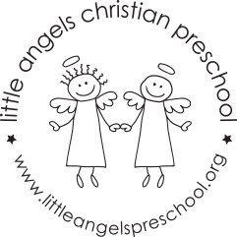
Dear Families,
The Library Area is a very important part of our classroom and of your child’s life. It’s where children gain the foundation for reading and writing. It’s also a place where children can relax and enjoy the wonderful world of children’s books.
We encourage children to look at books, to listen to taped stories, to retell stories and to scribble and “write” throughout the day.
We read stories to the children every day. Reading introduces new ideas, helps children learn how to handle problems that come up in life, and mostly encourages them to develop a love for books. As children listen to us read, their own reading skills begin to develop. Here are some of the things we do as we read.
- We look at pictures and ask: “What do you see?”
- We encourage children to predict what will happen next: “What do you suppose will happen now?”
- We encourage children to repeat words, rhymes and phrases they’ve memorized.
What You Can Do At Home
Research has shown us the important role families play in helping children learn to read and write. The single most important thing you can do is to read to your child every day. When your child sits next to you as you read, he begins to connect books with good feelings. Here are a few more things you can do with your child.
- Encourage your child to talk about the stories you read.
- Ask questions like, “I wonder what will happen next?” or “I wonder why…”
- Try to relate the story to something in your child’s life (“That dog looks just like Grandpa’s”).
- Visit the library and check out books that interest your child.
- Give your child paper and pencils, pens, or markers and let him experiment with writing. Don’t worry if his writing isn’t perfect!
To keep your child’s home library well stocked, you can draw on the resources of your local public library. When you take time to read to your child every day, you are doing the very best thing to help your child grow up to be a successful reader.
Duplicated with permission from The Creative Curriculum for Preschool

