September | 2019

Snack Menu 100% juice and water are served at snack time
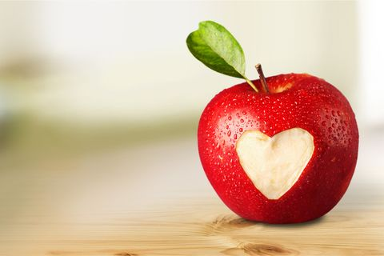
Sunday | Monday | Tuesday | Wednesday | Thursday | Friday | Saturday
1 | 2 | 3 | 4 | 5 | 6 | 7
 | No School  Happy Labor Day! | Veggie Straws | Cheerios | Cheez-its | Pretzels
8 | 9 | 10 | 11 | 12 | 13 | 14
 | Club Crackers  Raisins | Goldfish Crackers  Raisins | Nilla Wafers | Saltines | Wheat Thins
15 | 16 | 17 | 18 | 19 | 20 | 21
 | Life Cereal | Rice Cakes | Graham Crackers | Veggies Straws  Bananas | Cheerios  Bananas
22 | 23 | 24 | 25 | 26 | 27 | 28
 | Pretzels | Oyster Crackers  Oranges | Club Crackers  Oranges | Life Cereal | Ritz Crackers
29 | 30
 | Animal Crackers

