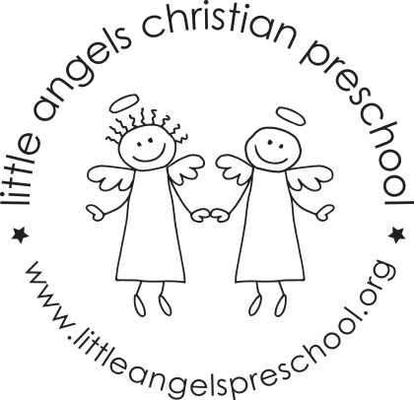

May 2019 Newsletter
Wow, this school year has just whizzed by. It’s hard to believe that it is May already!
It has been a great year, we have really enjoyed getting to know all of the children and watching them become so comfortable in our class.
During May, our themes will be fruit and veggies, mothers and families and we will end the year with kid’s choice and crazy days. During this week we will have some Christmas and other holiday themed table toys and we will sing “The Pumpkin on the Vine” and some other favorite songs and stories the children have especially enjoyed this year. In the sensory table we will have soapy water, rice and colorful packing peanuts.
For art we will paint with cookie cutters, use glue sticks and have free art for kid’s choice. Our dramatic play area will be a fruit and vegetable stand, a grocery store and housekeeping with babies and strollers.
We will be reading “I eat Fruit”, “Is Your Mama a Llama?” along with some of the children’s favorite stories, songs and flannel boards they have enjoyed this year.
We hope you will join us for the all school picnic on Friday May 24th this is always a fun day for everyone, more information will be sent home soon.
Thank you for sharing your children with us and have a great summer.
Martha Carroll and Maggie Killick

