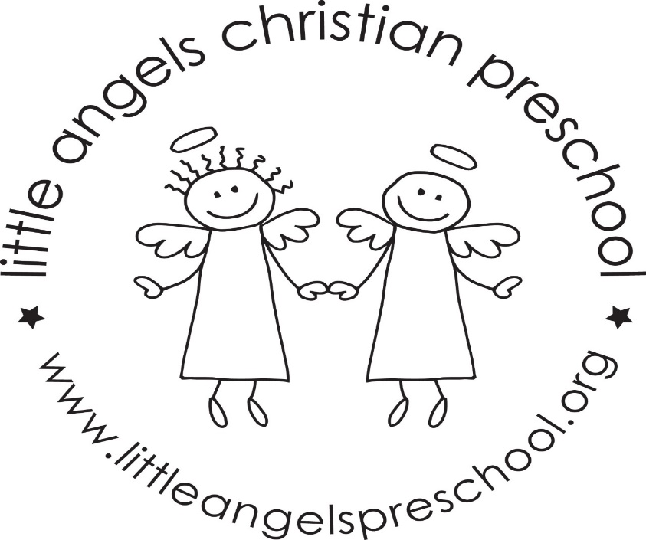
Welcome back! We hope everyone had a great spring break! We have a lot of fun things planned for the month of April.
We will learn about the one more of the five senses (hearing), as well as Easter and spring themes.
On April 10 & 11 we will celebrate meeting all of the letter people! We will have a letter people party! The classroom will have many different letter activities and puzzles, and of course a dance party. We’ll have a special snack with letters on it (cookies). Invitations were sent home in each child’s cubby.
The week of April 15 begins the Week of the Young Child. We will have special readers from the community every day. We will talk a lot about how special each child is. Each day will have a different theme and we will send reminders on shutterfly of the next theme. On Tuesday April 16 from 5:15-6:30 family fun night will be in the community room. We will have a special singer, and a pizza party. Sure to be a good time.
On April 19 Little Angels will be closed for Good Friday.
Thank you for sharing your child with us, and if you ever have any questions we are always available!
Mrs Dreys & Mrs Gierthy

