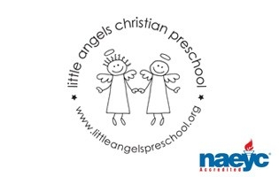
April 2019

Toddler Newsletter

Hello Toddler families! We hope you all had a relaxing Spring Break!
It was so nice meeting with many of you at conferences to talk about your little ones! What a joy it is for us to watch their growth each month! We feel so blessed to have such wonderful parents and kids!

We are especially excited to have some warmer temperatures and spend more time outside on the playground this month! We are looking forward to some fun events and themes this April. We will explore themes like Spring, Land, Sky, Water, and Easter. Your child’s artwork will be displayed during Week of the Young Child. We will also have special school activities and snacks planned for that week!

Dates to Remember

Monday - Thursday April 15-18 NAEYC Week of the Young Child with Art Show

(Each day will have a fun theme for dress up)

Monday- Hat Day and Music Monday
Tuesday- Western Day
Wednesday- Favorite Sports Team Day
Thursday- Pajama Day

Tuesday April 16 @ 5:30- 6:30 Spring Family Fun Night (Barnyard Music)

Friday April 19 No School Good Friday

Enjoy this Spring season and as always thank you for sharing your children with us!

Your Toddler Team,

Mrs. Laura Loppnow, Mrs. Lynda Katzbeck and Mrs. Christine Schaefer

