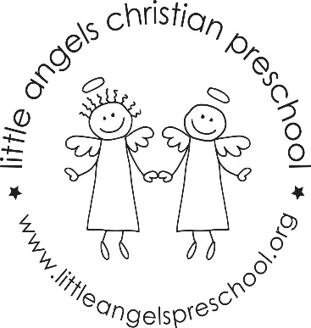WELCOME BACK!!!
We hope you all had a relaxing and fun break with your family. It is already April and we know from experience that the next two months will fly by. We have many new and exciting activities for your children this month. Our themes in April are…Rainbows…Easter…Our Earth…
The sensory table will have dried pasta, water, sand, clean recyclables and many other hands-on experiences. Our art activities will consist of gluing collages and many new painting projects that are sure to be tons of fun. We will display some of these at the annual art show.
We will continue to have chapel visits, music and movement and hopefully a lot of large motor time outdoors.
Keep looking at our emails and Shutterfly for any new announcements.
\
Happy Spring!!!
Martha Carroll and Maggie Killick

