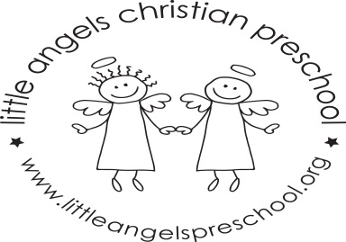
March Newsletter Two’s Class
Dear Parents,
Thank you all so much for the very generous books donated to our class during the book fair, we will enjoy reading them to the children.
During March our themes will be Smell, Touch, “St. Patrick’s Day” and Spring. We will have a doctor’s office, flower shop and housekeeping in the dramatic play area. For St Patrick’s Day we will have green table covers, napkins, plates etc.
For art we will be using finger paints, pastel crayons on sandpaper, painting with fragrant cool aid and experiment mixing together blue and yellow paints. We have a wide variety of table toys including puzzles, play dough and matching games. We will sing “5 Senses Song”, “Head Shoulders Knees and Toes” and enjoy some musical instruments. The children also enjoy their time with Mrs. Oehler during our music class each week.
Conferences will be on Thursday March21st. – No School! We will not have school on Friday March 22nd and for the week of March 25th due to Spring Break. We hope you have a wonderful and blessed break wherever you are spending it. As always, please do not hesitate to call, email or stop by with any questions or concerns.
Martha Carroll and Maggie Killick

