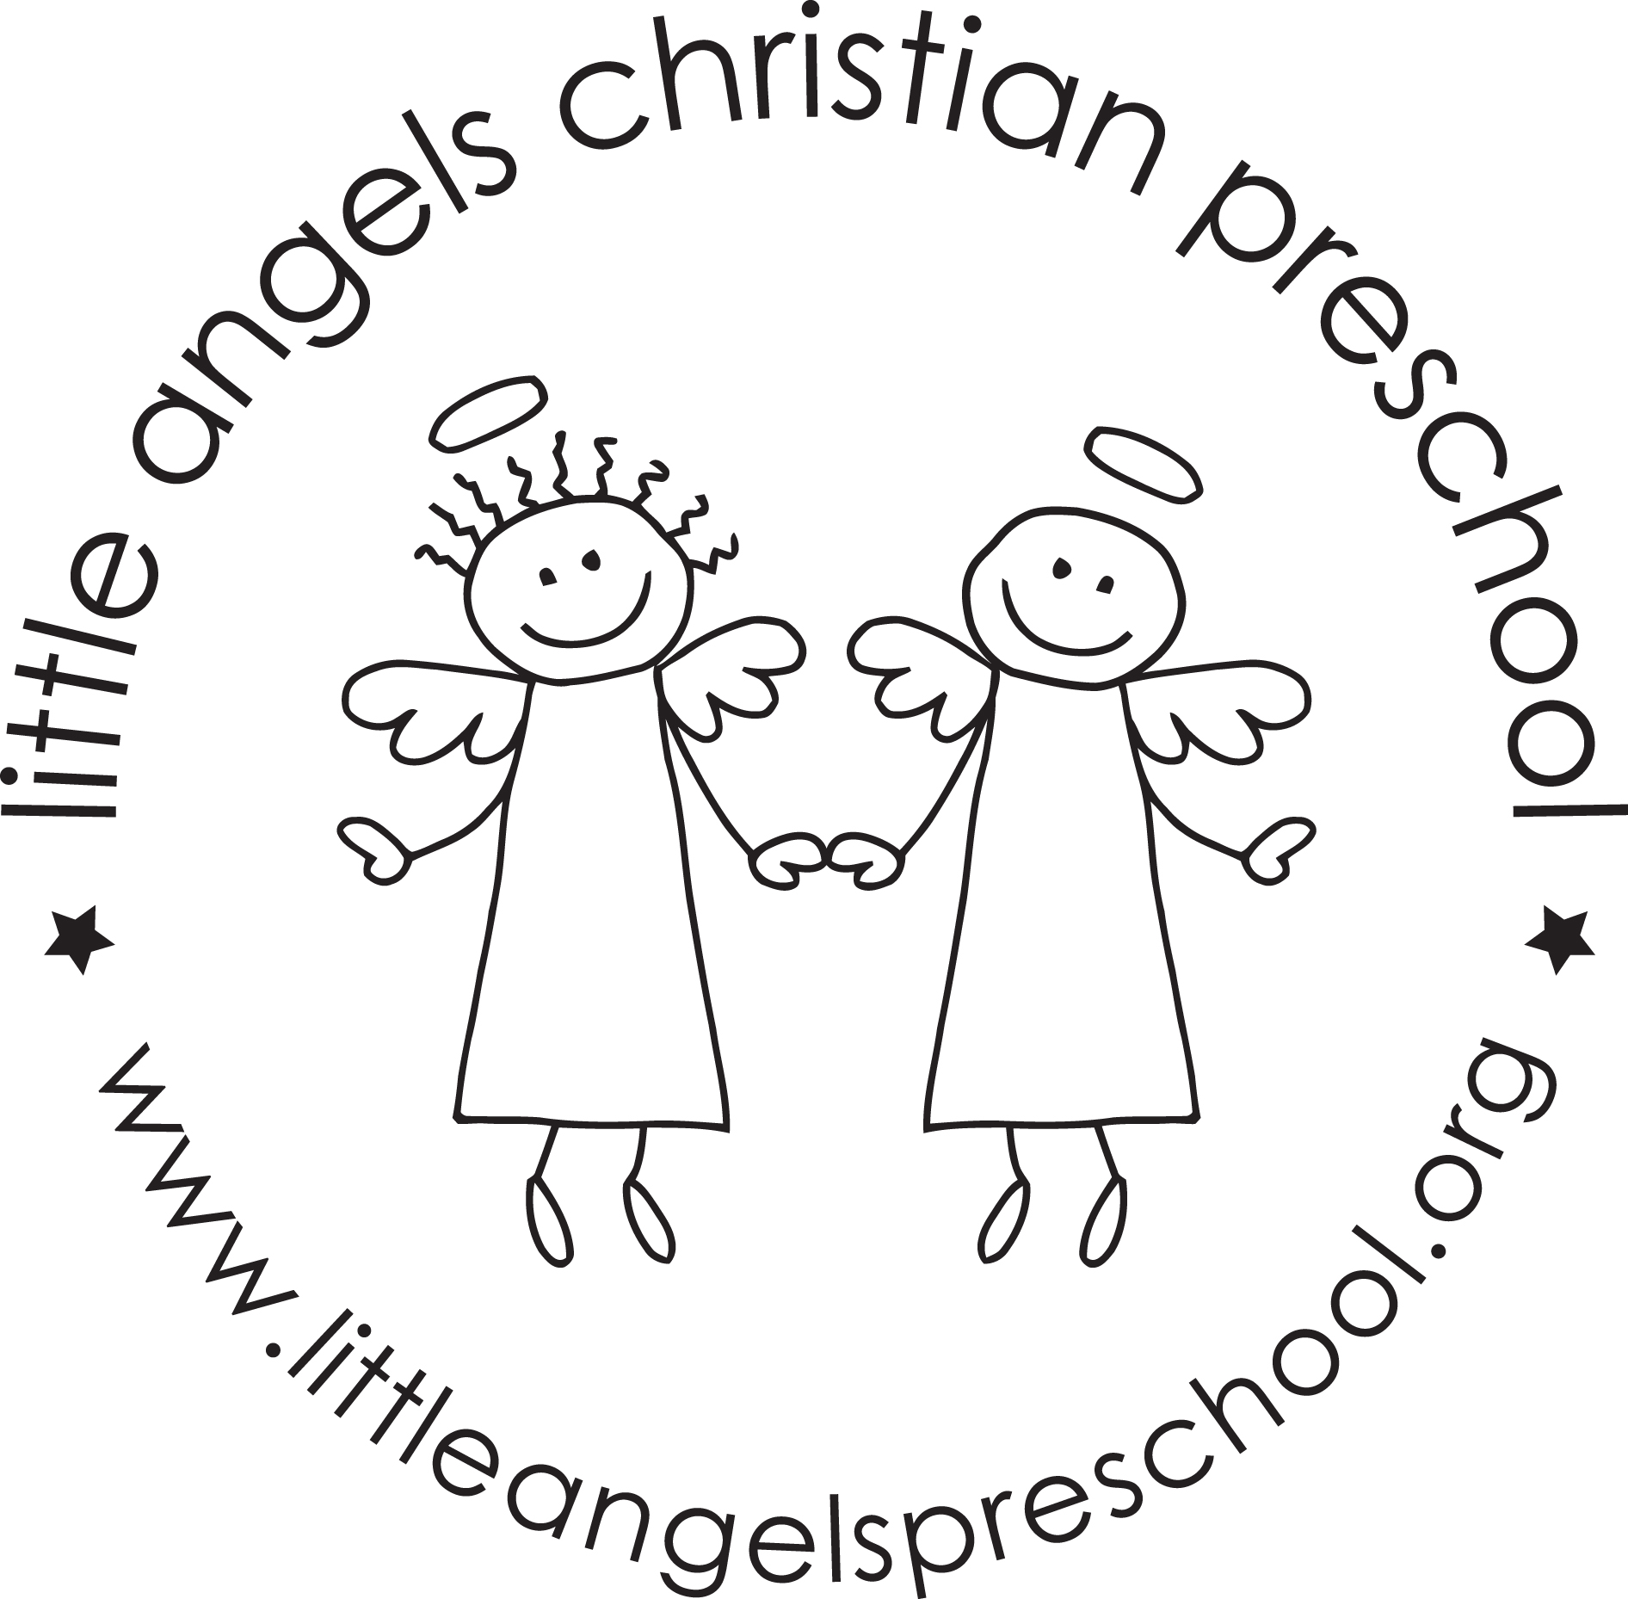March 2019
Three year old class

Wow, this year has been flying by! We have quickly headed into a fun filled March and we are so excited about all of the fun that we have in store for your children this month!
We will be spending the majority of this month talking about the five senses. We will talk with the children about how much our five senses help our everyday life. We will also talk about what is special and unique about each of these senses. We will be doing themed art work such as texture collages, painting with jello and painting with kool-aid! Our table activities are very engaging and versatile; they include exploring different textures, finding how different sounds are and using our sense of smell. It will be a fun month of learning all about our senses.
This month we will also be celebrating St. Patrick’s Day! Our room will be decked out in green shamrocks and leprechauns. The week of St. Patrick’s Day we will have a lot of fun with themed artwork and green table activities. We will even go on a Leprechaun hunt.
We will also have a visit from a Barrington area dentist. Our theme will revolve around our teeth on those two days.
We have been moving along with our Letter People and we will start the month meeting Ms. V. We are getting close to the end of the alphabet and we will have a Letter People party! We have also been learning the corresponding letter in sign language.
We hope your children have been sharing with you all of what they have been learning this year and look forward to all the fun learning that we still have in store for them this year!
Reminder: We will have conferences on Thursday, March 21 and the 13 days leading up to conferences. There will be no school on March 21.
We will be closed for Spring Break from Friday, March 22 through Sunday, March 31.
Your Three’s teaching team – Sue Dreys and Anne Gierthy

