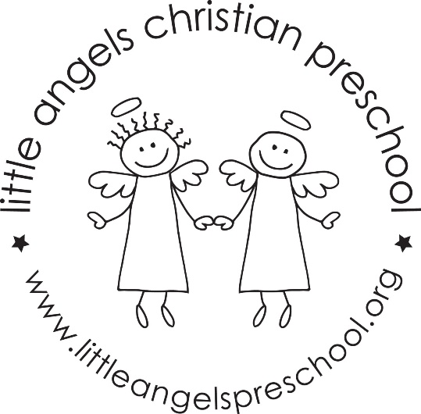

January 2019
We hope you all had a wonderful Christmas break and enjoyed lots of fun family time! We want to thank you for your generous gifts; it always makes us feel appreciated. We are excited to have the children back in school, and are looking forward to a great 2019!
During the month of January we will be talking about the alphabet for the first week, and then our theme will be snow for the rest of the month! We will have lots of fun activities, snowmen building, ice hockey and much more. We will continue meeting the letter people, and learning the letter in sign language.
We are also going to practice pouring water from a pitcher this month. Each child will pour their own water at snack time.
Please remember to bring outdoor clothing to school each day. We will try and go outside in the winter, if the wind chill is above 20.
Reminder: We will be closed on January 21 for MLK Jr Day.

